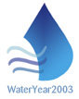





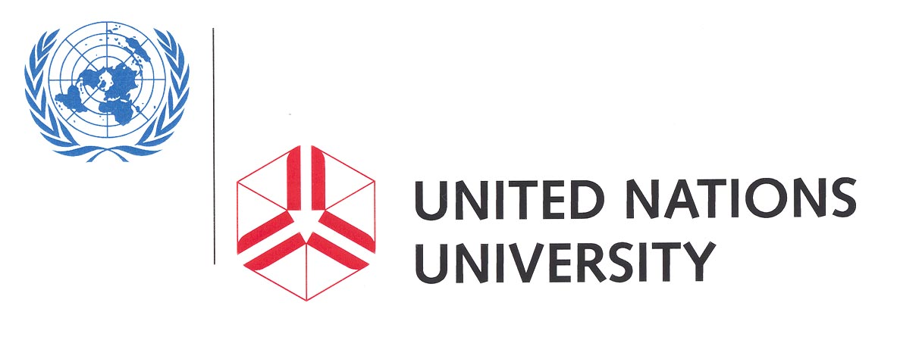 United States International University

Nairobi “Headwater” Declaration
for the International Year of Freshwater 2003

We, the participants in the International Conference on Sustainable Management of Headwater Resources, held in Nairobi (Kenya) on 5-8 September 2002,

- Acknowledging with gratitude the United Nations General Assembly Resolution No. 55/196 to declare the year 2003 as the International Year of Freshwater, thus drawing the world's attention to the need to foster sustainable development and management of freshwaters;

- Noting the outcome of the recent World Summit on Sustainable Development in Johannesburg 2002, where commitments were made “to increase access to clean water and proper sanitation, to increase access to energy services, to improve health conditions and agriculture, particularly in drylands, and to better protect the world's biodiversity and ecosystems”;

- Recognizing that headwater regions are sensitive environments, source areas for both surface and groundwater resources, and lands that affect the quality of freshwater supplies;

- Keeping in mind that headwater regions lie at the margins of both watersheds and, often, social and economic systems;

- Recognizing also the critical environmental functions of headwater regions and their importance for the livelihoods of both their inhabitants and for those who inhabit lands downstream as evoked in Chapter 18 “Protection of the quality and supply of freshwater resources: application of integrated approaches to the development, management, and use of water resources” of Agenda 21 adapted at the United Nations Conference on Environment and Development (1992), and also as stipulated in its Chapter 13 entitled “Managing fragile ecosystems: sustainable mountain development”;

- Affirming our concern to mitigate the consequences of the increasing human impact in headwater regions caused by competing demands for water, forestry, agriculture, energy production, tourism, transport and urban development, which continue to affect the environment adversely, not least with respect to the provision of clean water supplies and the maintenance of other hydrological functions;

- Noting with further concern that policies can impair, seriously and inadvertently, the course of headwater resources management, and that this can create problems downstream for the quality, quantity and distribution of available freshwater resources;

- Recognizing that sustainable management of headwater regions needs a holistic, integrated approach which respects the needs of all stakeholders in the regions, values and empowers the headwater inhabitants, and which recognizes their central role in the stewardship of headwater systems;

- Affirming that the sensitive and scientific management of natural resources, supported by improved access to the high quality data required is essential for fostering development that is not only sustainable, but ideally self sustaining;

- Conscious that unsustainable management has negative impacts on the health, productivity, social and economic welfare and ecosystems of headwater regions;

- Aware of the increasing demand for potable waters that will be required for human health, welfare and well-being, and of the crucial role that headwater regions will play in meeting this demand;

- Conscious also of the potential negative interactions between the inhabitants of headwater regions and those downstream, including coastal areas, caused by competition for the limited resources available in the regions, and aware also that headwater areas accommodate and provide for livelihood of a large number of populations, whose activities and resources consumption may have significant effects on the well-being of those who live downstream;

Declare that:

- Sustainable development should be the baseline for all environmental policy, planning, management practice, education and law in headwater regions;

- UN agencies should continue their work with all stakeholders to appraise their situations, to identify gaps in knowledge, needs and constraints, and to support them in their efforts to resolve their problems and undertake practical action towards more self-sustaining and environmentally sensitive development;

- An ‘international commission’ for headwater management should be established in order to provide direction and continuity for headwater issues and to create an awareness of headwater concerns at governmental level;

- Priority should be given to the creation of new management structures at all levels, which should be designed to improve the coordination, cooperation and empowerment of all stakeholders of headwater regions, not least to enhance the participation of women, disadvantaged social groups and minority communities, and to tap and develop the full spectrum of local indigenous knowledge relating to watershed planning and management;

- Greater effort should be devoted to the refinement of methods for generating and sharing the appropriate and reliable information needed for environmental research, planning and management and also for the transfer of appropriate low cost technologies, especially with respect to ‘cushioning’ the impacts of environmental hazards for human populations;

- Greater attention needs to be paid to the special roles and hydrological functions of headwater wetlands and peat lands, which should be a special focus for future headwater workshops, and also to the impacts of anthropogenic processes on watershed functions in headwater regions;

- The quality of life for the inhabitants of headwater regions should become a primary concern, including the basic needs for a healthy environment and the regeneration of degraded headwater habitats where required;

- Greater attention should be paid to applied environmental education aimed at building capacity for headwater management and changing social attitudes against wasteful and polluting uses of headwater resources;

- NGOs (community-based non-governmental organizations devoted to environmental and/or social uplift) should be empowered to play a greater role in the planning, regeneration and management of headwater habitats, by promoting more efficient mechanisms for financial support for effective NGOs;

- Greater attention should be given to management of headwaters in arid and semi-arid lands, especially with respect to groundwater management and improved accessibility of potable waters to headwater inhabitants, while the one of the main focuses should be to reduce the time wasted in carrying water to households from distant water sources;

- Attention should also be paid to alternative measures that would reduce the dependence of downstream areas on the resources of headwater areas, including reducing wastage and increasing the efficiency of resource utilization, not least of water;

- The equitable distribution and use of headwater resources remain a major concern, and planning and management of headwater regions needs to be integrated within the broader framework of watershed management that addresses the concerns of both headwater inhabitants and those downstream, including those living in coastal areas.

We therefore call upon UNU, UNESCO, UN-HABITAT, FAO, UNEP, UNDP and other concerned international and national organizations, governments of both developed and developing countries, corporations and NGOs, to facilitate headwater research, monitoring, capacity-building, self-sustaining sustainable development, and better management of the headwater environments, and to help create linkages and synergies in this regard among environmental managers, scientists, communities, policy/decision-makers, practitioners and the general public.

*************

